### DESIGN PROJECT REPORTS OF E-LEARNING DESIGN

### LA solution----STEM curriculum design learning and practice tools

Liu yunmeng

Yu xiaoxue

Li jiaxuan

Yu qing

Zhou yumen

2020.1.5

*Abstract:*

With the continuous development of China's economy, the Chinese government also attaches increasing importance to STEM education.STEM teachers tend to be lack of relevant professional knowledge on STEM curriculum design. And there are little products on providing STEM trains, so we decide to develop this platform.It mainly includes five functions:Tutorial、Designing、[Case](E:/Dict/8.7.0.0/resultui/html/index.html" \l "/javascript:;) [Library](E:/Dict/8.7.0.0/resultui/html/index.html" \l "/javascript:;)、Discussion、Personal Center.The result shows that people will be willing to use our platform,and the overall expected goals can be realized roughly.We mainly design and develop our STEM E-learning platform by WIX tool, the next step we plan to further improve and perfect our project in the future.

# 1.0 Introduction

With the development of the current economic environment, enterprises in various countries have an increasing demand for talents with multidisciplinary backgrounds and abilities.In order to improve their international competitiveness and ensure their economic dominance, western countries, led by the United States, took the lead in implementing STEM talent cultivation programs.With the continuous development of China's economy, the Chinese government also attaches increasing importance to STEM education. The white paper on China's STEM education issued in 2017 systematically elaborated the source, development and advanced cases of STEM education in western developed countries, and mapped out the development plan and route of STEM education in China.At present, in the practice of STEM education in primary and secondary schools, one of the most prominent problems is the serious shortage of STEM teachers and the lack of professional quality, which urgently needs the professional training and improvement of STEM teachers.

For this reason, our team designed and developed a tool called STEM curriculum design learning and practice. We used the constructivist learning theory to provide a contextualized online learning environment for pre-service teachers and in-service teachers, supplemented by well-designed tutorials and rich case database, so that learners can "learn by doing and learn by doing".In this way, STEM teachers can learn and master the methods of STEM curriculum design and improve their professional quality.We mainly used WIX platform for design and development, and built a simple framework of the platform, but all functions were available.

* 1. **Initial Needs Statement**

There is no dedicated to STEM the professional teachers, many of the STEM may be a subject teachers as teachers, they exist in the field of STEM curriculum design is the lack of, at the same time, the majority of college students also need professional system STEM curriculum design study, on the whole, requirements can be divided into two points: the first is the STEM of the standard curriculum design tutorials, the second is the classic sample: STEM curriculum design resources, the third is the support of experts and learning community.Based on these needs, and finding that there are few products of this type in the market, we decided to design and develop an online learning and design platform for STEM courses for STEM teachers to fill the gap in the market.

# 2 Customer Needs Analysis

Whether a set of software development is successful or not is a key factor in meeting user needs. How do system requirements come about? Do users clearly describe their needs? How to translate user needs into an automated way? The development of software is actually a process of starting from one problem to another and solving them one by one. The analysis of the entire requirement is shown below.

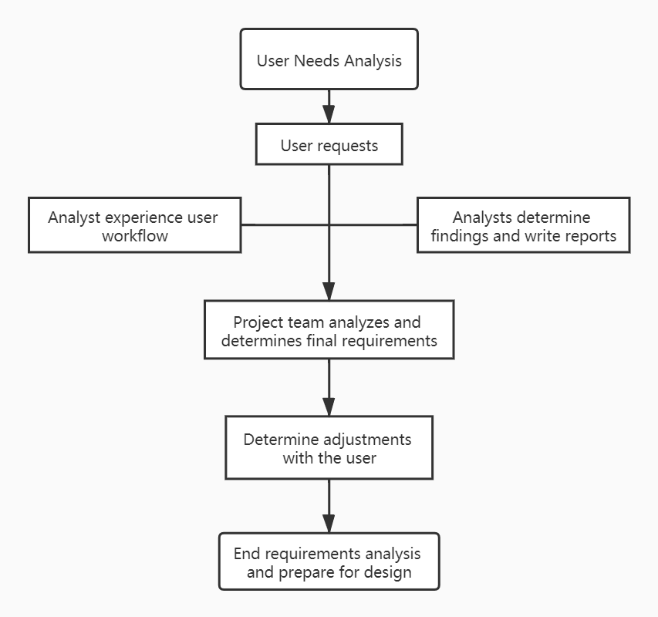

**Figure 2.1 Customer needs analysis process**

## 2.1 Customer Needs

This platform is for teachers and students who are interested in STEAM instructional design. The overall requirements of the platform should meet the following requirements:

1. Provide the function of STEAM course design tutorial and hands-on production of STEAM course;

2. Ability to download and upload user-designed courses, users can watch other people's works, and provide likes, collections, shares and comments, etc.

3. Provide community for users to conduct special discussions and ask questions to STEAM curriculum design experts;

4. Provide excellent case areas recognized by experts;

5. Users can view personal learning and viewing records, their own courses and postings, and interactions in the personal center;

6. Dividing the corresponding function menu according to different business, the human-computer interaction interface strives to be simple and beautiful. It has a good user-friendly interface for users of the system. Due to the uncertainty of user proficiency, corresponding utterance prompts must be made on the interface.

## 2.2 Weighting of Customer Needs

### 2.2.1 AHP Algorithm

The AHP algorithm is the analytic hierarchy process. This method breaks down the problem into different constituent factors according to the nature of the problem and achieves the overall goal. According to the mutual relationship and membership relationship between the factors, the factors are aggregated and combined at different levels to form a multilayer The analysis of the structural model finally comes down to the relative importance of the lowest level (schemes, measures, indicators, etc.) relative to the highest level (overall goals) or the relative priority.

The specific implementation steps of the algorithm are as follows: the first step is to clarify the problem; the second step is to establish a hierarchical structure; the third step compares various factors of the same membership relationship at a certain level to form a comparison judgment matrix, and Calculate the maximum feature root of the matrix and the corresponding feature vector to obtain the relative importance weights of the factors at this level; the fourth step is to weight the synthesis with the relative importance weights of the factors at the previous level to obtain the index of each layer Sorting weights of the target layer.

Explanation:

(1) In order to check whether the results obtained by the decision analysis method are basically reasonable, a consistency check is performed on the judgment matrix, and the consistency index of the judgment matrix is judged by Formula 1.

 **Formula 1**

Among them, n is the matrix order, and λ is the maximum eigenvalue of the matrix. The so-called eigenvalue means that for a square matrix A, if the value λ makes the equation system Ax = λx have a non-zero solution vector, λ is called the eigenvalue of the square matrix A.

(2) Compare the consistency index of the judgment matrix with the consistency index of the same random judgment matrix to get the coordination rate CR, which is calculated by Formula 2.

 **Formula 2**

Among them, RI is the consistency index of the corresponding random judgment matrix, and its value is shown in Table 1.

**Table 2.2.1 Consistency index values of the random judgment matrix**

|  |  |  |  |  |  |  |  |  |  |  |  |  |  |  |  |
| --- | --- | --- | --- | --- | --- | --- | --- | --- | --- | --- | --- | --- | --- | --- | --- |
| n | 1 | 2 | 3 | 4 | 5 | 6 | 7 | 8 | 9 | 10 | 11 | 12 | 13 | 14 | 15 |
| RI | 0 | 0 | 0.58 | 1.12 | 1.24 | 1.32 | 1.41 | 1.45 | 1.45 | 1.49 | 1.51 | 1.54 | 1.56 | 1.58 | 1.59 |

In general, the judgment matrix of order 1 or 2 is always completely consistent. For judgment matrices of level 2 and above, if the coordination rate CR <0.10, then the judgment matrix can be used, otherwise the judgment matrix should be adjusted until CR <0.10.

### 2.2.2 Weighting of Customer Needs

Customer needs and weighting are shown in Table2.2.2:

**Table 2.2.2Initial Customer Needs List Obtained from Interviews and Observations**

|  |
| --- |
| 1. User friendly (0.23)   Intelligent learning and recording  Intelligent Recommendation  Simple and elegant interface   1. Abundant content (0.33)   Multidisciplinary resources  Multi-form resources  Expert Resources   1. Quality Tutorial (0.27)   Easy to learn  A structured teaching process  Encourage hands-on design   1. Stability and safety (0.17)   Login Security  Platform running stably |

# 3 Revised Needs Statement and Target Specifications

After the initial platform was set up, we invited some students to learn the platform and got a lot of good suggestions for modification.

1. In order to ensure the effective implementation of the hands-on design, a mouse hover effect has been added to each column of the hands-on design form. If the user has forgotten the content of the teaching part, he can click the floating box to clarify the design points of the content;

2. In order to ensure the scientific and healthy work of users, all uploaded works need platform review;

3. If the author opens the download function, the user can download the form of the work;

4. Each excellent case in the case library must have a lesson plan, a lecture video or a recording video, and users are encouraged to upload videos;

5. The user does not set a question area when browsing the tutorial. If there are questions, they can go to the forum area for questions and discussions.

After the design was revised, the students who gave opinions were evaluated again, we got good reviews.

# 4.0 External Search

The overall framework of the project is shown below.

Learning

Interaction

Experience

Behavior mental

Experts and others

Course content

Knowledge &skills & attitude

Practicing

Practicing

Figure 4.1 The overall framework of the project

Our design still needs to focus on the learning experience of learners, which is related to the learning effect of users on the one hand and the sustainable development of products on the other.The first is the design of the interface, which is the most direct visual experience of the user;The second is the design of resources, which is the core part of the product.At present, there are few similar products in the market, so our design is based on other similar products, drawing on the general design of some learning products, and our own innovation to build an online learning platform for STEM teachers.

## 4.1 Benchmarking

### Table 4.1 Basic functions of Product

|  |  |  |  |  |  |
| --- | --- | --- | --- | --- | --- |
| **Dimension**  **Function** | **Tutorial** | **Designing** | **[Case](E:/Dict/8.7.0.0/resultui/html/index.html" \l "/javascript:;) [Library](E:/Dict/8.7.0.0/resultui/html/index.html" \l "/javascript:;)** | **Discussion** | **Personal Center** |
| 1 | Instructional objects | Topics | Classic cases | With Experts | [Relevant](E:/Dict/8.7.0.0/resultui/html/index.html" \l "/javascript:;) [information](E:/Dict/8.7.0.0/resultui/html/index.html" \l "/javascript:;) |
| 2 | Instructional objectives | Instructional objects | Users’ cases | With Users | My posts |
| 3 | Learning situation | Instructional objectives |  | With machine | My design |
| 4 | Instructional tasks | Learning situation |  |  | My comments |
| 5 | Learning activities | Instructional tasks |  |  | My footprint |
| 6 | Learning assessment | Learning activities |  |  | [Personal](E:/Dict/8.7.0.0/resultui/html/index.html" \l "/javascript:;) [information](E:/Dict/8.7.0.0/resultui/html/index.html" \l "/javascript:;) |
| 7 |  | Learning assessment |  |  |  |

The overall page is designed and developed by WIX, and the page size is automatically adapted with the browser. Users can switch the size according to their needs.At the same time, the response time of each interactive function is short, the use is very smooth, the performance is better.

### Table 4.2 Benchmarking of Products

|  |  |  |  |  |  |  |  |
| --- | --- | --- | --- | --- | --- | --- | --- |
| Scale | **Lower Border** | **Bad** | **Below Average** | **Above Average** | **Good** | **Excellent** | **Mean** |
| **Attractiveness** | -1.00 | 0.7 | 0.47 | 0.39 | 0.27 | 0.67 | 1.77 |
| **Perspicuity** | -1.00 | 0.71 | 0.54 | 0.48 | 0.27 | 0.5 | 1.59 |
| **Efficiency** | -1.00 | 0.57 | 0.48 | 0.43 | 0.32 | 0.7 | 1.69 |
| **Dependability** | -1.00 | 0.77 | 0.36 | 0.33 | 0.23 | 0.81 | 1.65 |
| **Stimulation** | -1.00 | 0.5 | 0.49 | 0.32 | 0.24 | 0.95 | 1.55 |
| **Novelty** | -1.00 | 0.25 | 0.52 | 0.35 | 0.49 | 0.89 | 1.58 |

## 4.2 Applicable Constraints

Because we select the WIX to design our project , so it may be unstable occasionally.There are also some drawbacks, such as lack of [Case](E:/Dict/8.7.0.0/resultui/html/index.html" \l "/javascript:;) [Library](E:/Dict/8.7.0.0/resultui/html/index.html" \l "/javascript:;) resources、Learn analysis technology is not mature、functions are too simple and so on.

But undoubtedly, it has broad market prospects!

# 5 The KIEBIE analysis of you learning platform

## 5.1 Environment

The learning and practice tool of STEM curriculum design is a web application, which can be used to learn and practice in a network environment and communicate with other learners and experts in the discussion function to achieve a better learning experience.

## 5.2 Knowledge, Skills, Attitude

The design goal of the platform is to build a platform for learning, practicing and communicating how to design STEM courses to meet the individual needs of different learners.

### 5.2.1 Knowledge

To know the design elements and general process of STEM courses, including teaching objectives, design patterns, learning resources, teaching activities, subject integration, real problem situations, learning evaluation, measurement, etc. To understand the design principles and specific methods of each element through tutorials and cases.

### 5.2.2 Skills

Learn how to design STEM courses, reinforce the principles and methods for designing STEM courses, and put them into practice. Through in-depth communication with experts, scholars and other learners, the platform discusses the design difficulties of a certain element, integrates the shining points of excellent cases, and improves STEM courses.

### 5.2.3 Attitude

Through learning, learners can form a high sense of identity and affinity for STEM courses, eliminate the loneliness among learners in the course discussion and communication, develop passion and interest in designing STEM courses, and improve critical and creative thinking.

## 5.3 Behavior and mental process & status

Learners' learning behaviors of learning and practicing tools in STEM courses include individual learning behaviors, interactions with platforms, interactions with resources and social interactions. The interaction with the platform include registration, login and browsing. The interaction with resources includes browsing, uploading and downloading resources. Social interaction include asking teachers and other learners for help, creating posts, browsing posts, and reviewing on posts. Specific assessment criteria are shown in part 8.

## 5.4 Interaction

Interaction including learners' interactions with the platform, the interaction with the resource, social three categories, including learners' interactions with the platform such as registration, login, browse, embodies the learners at a design tutorials page after login platform, to design teaching in hands-on design page editor, upload, download, edit and if you have forgotten to through the help button for prompt. The interaction with resources includes browsing resources, uploading resources and downloading resources, which are embodied in the case database page. Learners can browse, upload and download excellent cases. Social interaction includes asking for help from teachers and other learners, creating topics, browsing topics and commenting on topics, which is embodied in forums and case Banks. Learners can post questions and answers on forums, browse posts and comment on case Banks, and interact with other learners and expert teachers.

## 5.5 Experience

Learners' experience is analyzed from the function of the platform, which is mainly analyzed from the following five functional areas: tutorial, design, case base, discussion and personal center: Learners can have a general understanding of how to design stem courses and achieve self-directed learning in Tutorial; realize collaborative learning and stimulate learning motivation in Design;

enrich learners' cognition of stem courses, and inspire new ideas in Case; help

learners solve problems, eliminate loneliness and stimulate learning motivation in Discussion; create a personal space for the learning community, and enhance self-efficacy in Personal center.

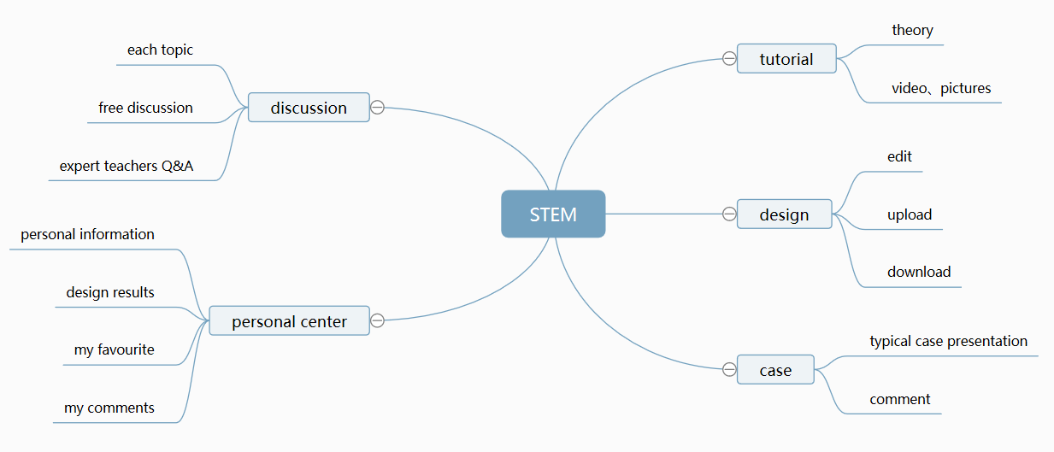

Figure 5.1 the structure of platform

## 5.6 Interact Object

The learning platform is aimed at serving and pre-service teachers with learning needs to design STEM courses.

## 5.7 Initial Screening for Feasibility and Effectiveness

Through the comparison, selection and integration of similar teaching platforms, based on the guidance of constructivism theory and the current situation of stem curriculum design, our group has determined that the theme is learning and practice tools for designing stem curriculum and has divided the tutorial plate, design plate, case base, discussion area and personal center, so as to provide learners with a platform for learning, practice and communication.

After the first report on the opinions of teachers and students, we have basically determined five sections, but the specific page details of the tutorial section and case library still need to be improved. So we have multimedia forms of presentation in the tutorial section, including text, pictures, videos, etc. The case page introduces the functions of "like", "collect" and "comment" of Bilibili APP, and sets the top ten ranking of hits. In this way, the platform design is more effective.

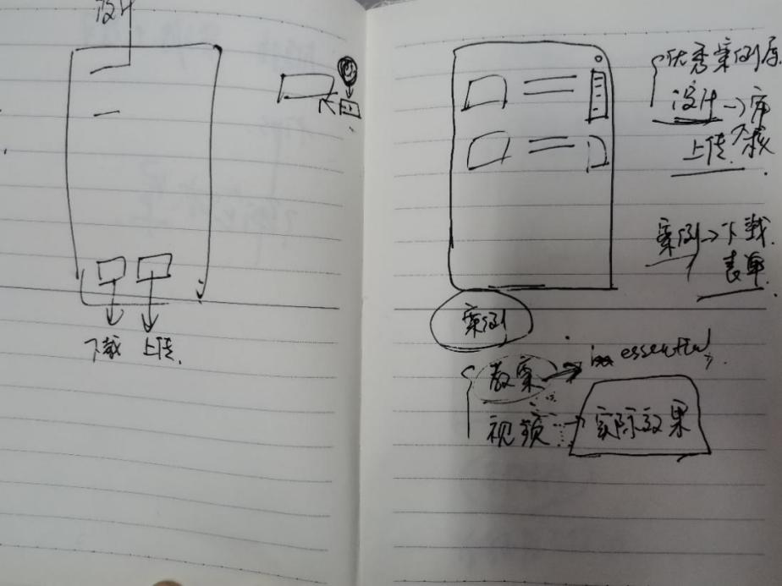

Figure 5.2 advice for case

After the preliminary design, during the feedback between groups, classmates put forward suggestions for the functions of the design plate and the discussion area. In the design plate, add a button to prompt help. In the discussion area, set sub topic discussion blocks so that learners can quickly find the answers they want to get, so that the platform design is more efficient and feasible, and give learners a better learning experience.

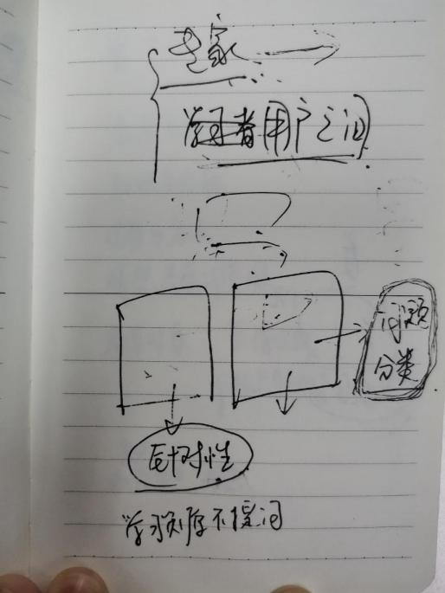

Figure 5.3 advice for discussion

# 6 Learning Theory

## 6.1 What learning theory do you mainly applying

Constructivism is a kind of complicated social science theory that has emerged in contemporary European and American countries since the 1990s. It is a theory that further develops after learning theory develops from behaviorism to cognitivism.

The constructivist learning theory emphasizes that students are the center, and the learning environment elements such as situation, cooperation and conversation should be used to give full play to students' initiative, enthusiasm and creative spirit, so as to effectively realize the purpose of constructing the meaning of current knowledge.*(Shen Jun, 2003)* "situation", "collaboration", "conversation" and "meaning construction" are the four elements of constructivist learning environment. Media is no longer a means and method to help teachers impart knowledge, but a cognitive tool to create situations, conduct collaborative learning and conversational communication, that is, to serve as students' active learning and collaborative exploration.

## 6.2 What do you applying this theory

### 6.2.1 Vivid and friendly interface design

Constructivism holds that learning is carried out in a certain environment, and the learning environment should be able to stimulate learners' interest in learning, help learners to establish learning situations, and promote the formation of correct learning motivation. Therefore, the design of teaching platform should not start from the analysis of teaching objectives, but from how to create a situation conducive to the construction of meaning. The design of the whole teaching platform should be closely centered on the "construction of meaning". The interface design of the online teaching platform largely determines the first impression of learners. If it can attract learners at the first time and brand the meaning of the course into their hearts, it will undoubtedly be of great help to stimulate learners' interest in learning and help students form learning motivation.

The target users of this platform are mostly in-service teachers and pre-service teachers, mainly young people. Therefore, the interface of this platform is designed with bright colors, striving to be vivid, lively, relaxed and friendly, in line with the cognitive psychology of young people. On the homepage, the meaning of this course is presented in a simple and abstract form, so that learners can subconsciously realize what is the use of learning these knowledge, and help them form the correct learning motivation and establish the learning situation. The layout of the website should be clear and focused, so that learners can easily establish connections with their own cultural background.

### 6.2.2 Sufficient content

Constructivism believes that learners should be able to explore freely and learn autonomously in the learning environment. In order to support learners' active exploration and completion of meaning construction, learners should be provided with various information resources during the learning process. The resources here are not only used to assist in tutorials and demonstrations, but also to support students' autonomous learning and collaborative exploration. Therefore teaching platform to STEM the curriculum design of the elements of each selected related knowledge, as Shared resources on the teaching platform, through the text, images, animation, video and other forms of flexible and vivid, thus increasing the learners' appeal, meet learners according to their abilities, interests and hobbies free learning needs. In order to help learners use the resources of the teaching platform, we have designed a variety of navigation and rich link functions, so that learners can easily find the resources they want.

### 6.2.3 convenient way to communicate

In order to make meaning construction more effective, teachers should organize and encourage collaborative learning and conversation as much as possible, and guide the process of collaboration and conversation toward the direction conducive to meaning construction, which is one of the main advantages of network teaching platform. Online teaching platform can help teachers and students to conveniently carry out collaborative learning and communication through forums, breaking the boundaries of time and space in traditional ways. In order to facilitate teachers to answer questions and communication between teachers and students, the teaching platform has set up a forum board. Learners can initiate discussions to seek solutions to problems they are concerned about or confused about, and they can also answer questions raised by others or participate in discussions. Teachers can answer questions or ask questions to guide learners to study and discuss.*(Li Tao & Xu Jianfei, 2011)*

# 7 Technology applying

The most valuable techonology and application are as follows:

## 7.1 The platform automatically generates design reports for users to download.

When user finished designing the lesson plan, including the course topic, the target student,

learning goal, learning scenario, learning task and activity, learning evaluation, he can click the "save" button to save the current design scheme. And then the system will automatically generate a PDF document. When the user clicks the "download" button, he can download the design report.

## 7.2 Feedback result of learning analytics to user.

The feedback including three aspects: online learning behavior, learning mode and design result score.This result is derived from the analysis in **part 8**. Part 8 shows more details. The following figure is the template style of the report sheet.

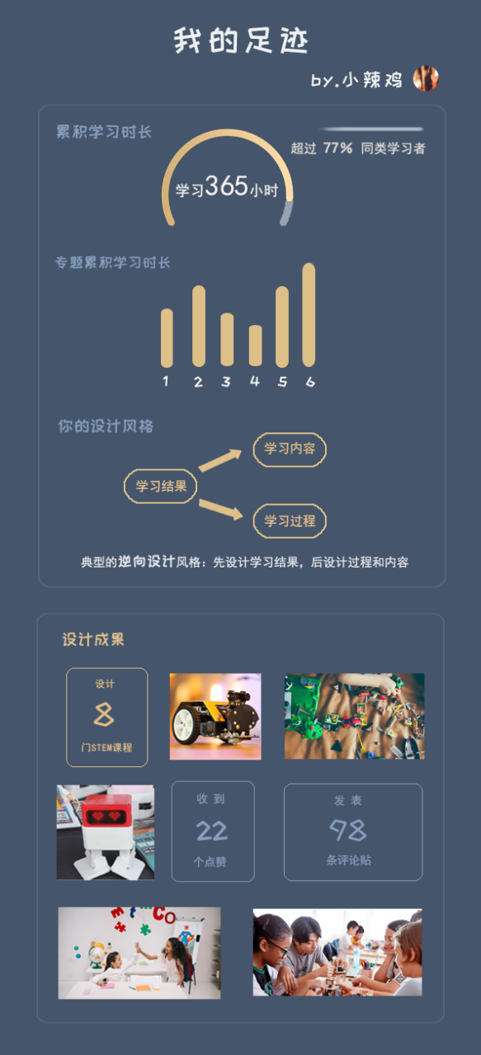

## 7.3 Statistics and visual presentation about the learning of various learning topics on the platform.

The purpose of this part is to help users better understand which learning contents similar learners pay more attention to, and guide beginners to choose learning materials.

The bar chart shows the cumulative number of students in each topic, so that users can intuitively understand the key learning contents of similar learners.

The bar chart shows the cumulative collection of each topic and reflects the potential learners of the topic.

The graph shows the changing trend of the number of students in each subject in the last six months and predicts the future trend.

## 7.4 Personalized recommendation of learning materials.

The platform recommends learning materials based on users' browsing records, tag records and learning records: learning materials for each topic are presented for user from the most match to the least match.

# 8 Learning Analytic

We will conduct three aspects of analysis: the analysis of learners' online learning behavior, the pattern/path that learners follow in designing the course, and the level of the course designed by learners

## 8.1 What data do you need?

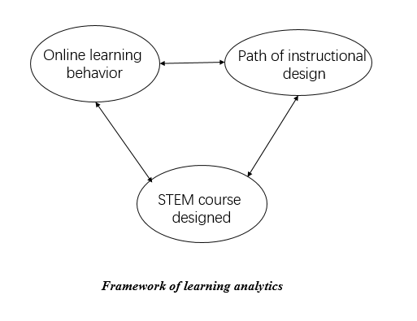

**Figure 8.1 framework of learning analysis**

### 8.1.1 Analysis of online learning behavior

We aim to analyze four kinds of online learning behavior, including independent learning behavior, interaction with platform, interaction with resources and social interaction. Figure 2 shows the results.

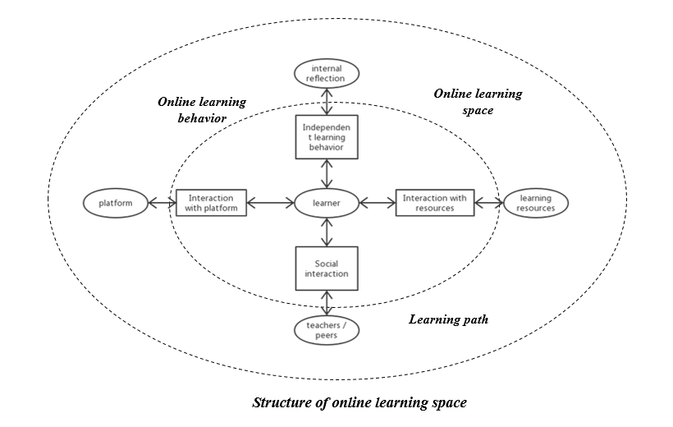

**Figure 8.2 structure of online learning space**

Specificly, independent learning behavior is reflected in how long the user learns some learning materials from he entered the specified learning page to exist the same page, how many courses that the user has designed. Interactive behaviors consist of interaction with platform, learning resourses and social interaction, which are shown in detail in **Table 1.**

**Table 8.1 online learning behavior**

|  |  |  |
| --- | --- | --- |
| ***Category of learning behavior*** | ***Typical behavior*** | ***Measurement*** |
| **Independent learning behavior** | learning duration | how long the user learns some learning materials from he entered the specified learning page to exist the same page |
| learning outcome | how many courses that the user has designed |
| **Interaction with platform** | register | time |
| log in | number of log in / online duration / interval of log in |
| **Interaction with resourses** | browse resourses | number of browsing behavior / duration of browsing behavior |
| tag resources | number of tagging resources that uses are interested in |
| download resources | number of downloading behavior |
| **Social interaction** | create posts | number of creating posts |
| review on posts | number of review posts |

### 8.1.2 Analysis of instructional design mode

There are two typical mode when designers design a course, including forward path and backward mode. Forward design means developing a curriculum through moving from input, to process, and to output. Central design means starting with process and deriving input and output from classroom methodology. Backward design starts from output and then deals with issues relating to process and input.

From the design path, we can conclude which mode the design process is categorized into. When users get the answer about their design mode, they can clearly identify which parts are more important.

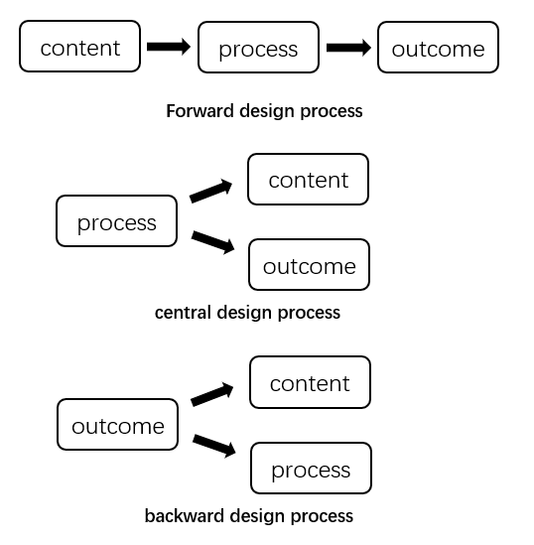

**Figure 8.3 Three typical design mode**

### 8.1.3 Analysis of STEM course designed

Every STEM course will be downloaded and distributed to experts in STEM course design. Expers will assess the courses based on scales and personal experience. The designer will receive a feedback about his design outcome.

For researchers, exploring the relationship among quality of course, design mode and designer’s online learning behavior maybe interesting and meaningful. Hence, we also forcus on the quality of STEM course designed.

## 8.2 How will you capture that data?

We will capture data in two ways: 1) embed xAPI into our online platform to track user’s learning behavior; 2) download the learning outcomes from database. The data collected via xAPI will be useful for analysing online learning behavior and design mode. And the downloaded files will be used to analyse user’s learning outcome. Furthermore, we aims to establish a relationship between the data from two sources.

**Table 8.2 Data collection**

|  |  |  |
| --- | --- | --- |
| ***Data*** | ***Category*** | ***Collection*** |
| **Online learning behavior** | **Interaction with platform** | ***xAPI:***   1. Registration time 2. Log in time 3. Log out time 4. Number of log in |
| **Interaction with resources** | ***xAPI:***   1. Number of browsing resources 2. Duration of browsing resources 3. Nuber of tagging resources 4. Number of downloading resources |
| **Social interaction** | ***xAPI:***   1. Number of creating posts 2. Number of review posts |
| **Design mode** | **Path of design** | ***xAPI:***  Record when the user designed which part of the curriculum |
| **Learning outcome** | **STEM curriculum designed** | Download source file from database |

## 8.3 How will you structure the data?

Having determined what data to capture and how to capture it, we outline the structure of a xAPI statements and the considerations we need to think about as a designer.

**Table 8.3 Structure of xAPI**

|  |  |  |
| --- | --- | --- |
| ***Element*** | ***Explanation*** | ***Considerations*** |
| Actor | Anyone who has registered for the platform is treated as a learner | * Any single person is possible to use the platform if only he is interested in STEM curriculum design, like in-service teacher, pre-service teacher, student or others. * User’s data is only used to study how to improve learning performance without divulging personal privacy information |
| Verb | * Button “register” * Button “log in” * Button “log out” * Button “learn” resourse * Button “tag” resources * Button “download” resources * Button “create” posts * Button “review” posts * Button “design” a curriculum * Button “save” the design * Button “upload” the design | * xAPI will capture when did the action happen in order to calculate user’s learning duration * The number of each behavior will be calculated manually later |
| Object | * Learning resources in the page of “tutorial” * Discussion posts in the page of “discussion” * Path of design in the page of “start your design” * Interaction with platform in the page of “register/log in/ log out” | * In terms of design mode/path, It is important to record the time when users fill in each part of the lesson plan in order to In order to analyse the behavior sequence pattern |
| Result | Click the button “upload” curriculum means finished the current design | * We will analyse quality of design via peer-review |
| Timestamp | When the above action happened need to be recorded | * Timestamp will be used for Behavior sequence analysis |

The model of learning analytics are as follows **(Figure 4).** Statistical analysis methods mainly consist of correlation analysis and behavior sequence analysis basen on classify and cluster.

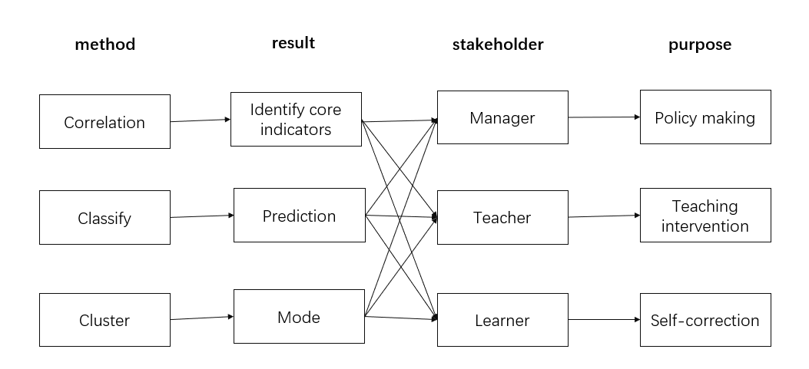

**Figure 8.4 Model of learning analytics**

# 9 UX evaluation

We perfected the design of the platform and demonstrated it in the last class.Students can also experience it on the computer by themselves. Then we sent out an online questionnaire and received 20 valid questionnaires.

The distribution of gender ratio is as follows:

**Figure 9.1**

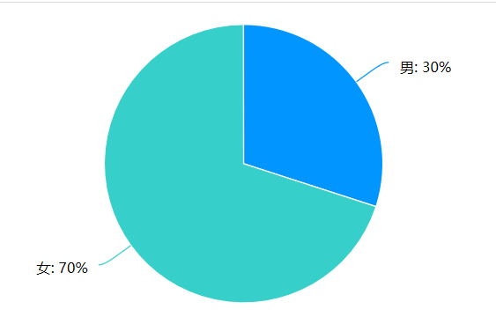

The final users have a high degree of willingness to use, with an average score of 7.75 (total score of 9). The score distribution of each degree of willingness to use is as follows:

**Figure 9.2**

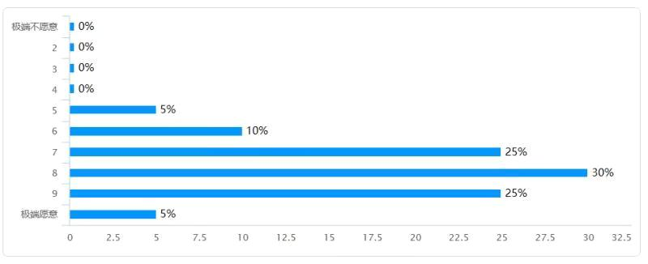

**9.1 result**

It can be seen that Mean and Variance in six dimensions from table 9.1,their means are all positive,what indicate that users have a good experience in using our E-learning platform.

**Table 9.1**

|  |  |  |
| --- | --- | --- |
| **UEQ Scales (Mean and Variance)** | | |
| **Attractiveness** | 1.767 | 0.44 |
| **Perspicuity** | 1.588 | 0.59 |
| **Efficiency** | 1.688 | 0.53 |
| **Dependability** | 1.650 | 0.64 |
| **Stimulation** | 1.550 | 0.80 |
| **Novelty** | 1.575 | 0.81 |

The details of the six dimensions can be seen in the figure 9.1.

**Figure 9.3**

**Table 9.2**

|  |  |
| --- | --- |
| **Pragmatic and Hedonic Quality** | |
| Attractiveness | 1.77 |
| Pragmatic Quality | 1.64 |
| Hedonic Quality | 1.56 |

**9.2 Confidence intervals**

As is shown in the table , 5% Confidence intervals for six scales.Every scale include 20 numbers.We can see the Mean and Std.Dev of each scale and item from table 9.3 and 9.4.

**Table 9.3**

|  |  |  |  |  |  |  |
| --- | --- | --- | --- | --- | --- | --- |
| **Confidence intervals (p=0.05) per scale** | | | | | | |
| **Scale** | **Mean** | **Std. Dev.** | **N** | **Confidence** | **Confidence interval** | |
| **Attractiveness** | 1.767 | 0.665 | 20 | 0.292 | 1.475 | 2.058 |
| **Perspicuity** | 1.588 | 0.766 | 20 | 0.336 | 1.252 | 1.923 |
| **Efficiency** | 1.688 | 0.729 | 20 | 0.320 | 1.368 | 2.007 |
| **Dependability** | 1.650 | 0.800 | 20 | 0.351 | 1.299 | 2.001 |
| **Stimulation** | 1.550 | 0.894 | 20 | 0.392 | 1.158 | 1.942 |
| **Novelty** | 1.575 | 0.900 | 20 | 0.394 | 1.181 | 1.969 |

**Table 9.4**

|  |  |  |  |  |  |  |
| --- | --- | --- | --- | --- | --- | --- |
| **Confidence interval (p=0.05) per item** | | | | | | |
| **Item** | **Mean** | **Std. Dev.** | **N** | **Confidence** | **Confidence interval** | |
| **1** | 1.850 | 0.587 | 20 | 0.257 | 1.593 | 2.107 |
| **2** | 1.800 | 1.105 | 20 | 0.484 | 1.316 | 2.284 |
| **3** | 1.150 | 1.182 | 20 | 0.518 | 0.632 | 1.668 |
| **4** | 1.350 | 1.565 | 20 | 0.686 | 0.664 | 2.036 |
| **5** | 1.650 | 1.348 | 20 | 0.591 | 1.059 | 2.241 |
| **6** | 1.500 | 0.827 | 20 | 0.363 | 1.137 | 1.863 |
| **7** | 1.700 | 0.865 | 20 | 0.379 | 1.321 | 2.079 |
| **8** | 1.350 | 1.268 | 20 | 0.556 | 0.794 | 1.906 |
| **9** | 1.450 | 1.234 | 20 | 0.541 | 0.909 | 1.991 |
| **10** | 1.850 | 1.137 | 20 | 0.498 | 1.352 | 2.348 |
| **11** | 2.050 | 0.826 | 20 | 0.362 | 1.688 | 2.412 |
| **12** | 1.800 | 1.361 | 20 | 0.597 | 1.203 | 2.397 |
| **13** | 1.500 | 0.827 | 20 | 0.363 | 1.137 | 1.863 |
| **14** | 1.650 | 0.587 | 20 | 0.257 | 1.393 | 1.907 |
| **15** | 1.900 | 0.788 | 20 | 0.345 | 1.555 | 2.245 |
| **16** | 2.050 | 0.686 | 20 | 0.301 | 1.749 | 2.351 |
| **17** | 1.650 | 1.137 | 20 | 0.498 | 1.152 | 2.148 |
| **18** | 1.350 | 1.137 | 20 | 0.498 | 0.852 | 1.848 |
| **19** | 1.550 | 1.050 | 20 | 0.460 | 1.090 | 2.010 |
| **20** | 1.800 | 0.834 | 20 | 0.365 | 1.435 | 2.165 |
| **21** | 1.700 | 1.081 | 20 | 0.474 | 1.226 | 2.174 |
| **22** | 1.800 | 0.768 | 20 | 0.336 | 1.464 | 2.136 |
| **23** | 1.700 | 0.923 | 20 | 0.405 | 1.295 | 2.105 |
| **24** | 1.550 | 0.945 | 20 | 0.414 | 1.136 | 1.964 |
| **25** | 1.700 | 0.865 | 20 | 0.379 | 1.321 | 2.079 |
| **26** | 1.400 | 1.392 | 20 | 0.610 | 0.790 | 2.010 |

**9.3 Distribution of Answers**

We can see that the overall answer distribution from figure 9.6.

**Figure 9.4**

**9.4 Benchmark**

**Table 9.5**

|  |  |  |  |
| --- | --- | --- | --- |
| **Scale** | **Mean** | **Comparisson to benchmark** | **Interpretation** |
| **Attractiveness** | 1.77 | **Excellent** | 10% of results better, 75% of results worse |
| **Perspicuity** | 1.59 | **Good** | 25% of results better, 50% of results worse |
| **Efficiency** | 1.69 | **Good** | 10% of results better, 75% of results worse |
| **Dependability** | 1.65 | **Good** | 10% of results better, 75% of results worse |
| **Stimulation** | 1.55 | **Good** | 10% of results better, 75% of results worse |
| **Novelty** | 1.58 | **Excellent** | 10% of results better, 75% of results worse |

From the figure 9.5,we can see that our project shows the lowest performance in Perspicuity which lie in Above average level.While the other five dimensions all exceed the above average level,they distribute at GOOD level.

**Figure 9.5**

**9.5 Inconsistences**

**Table 9.6 shows**

**Table 9.6**

|  |  |  |  |  |  |  |
| --- | --- | --- | --- | --- | --- | --- |
| **Scales with inconsistent answers** | | | | | | |
| **Attractiveness** | **Perspicuity** | **Efficiency** | **Dependability** | **Stimulation** | **Novelty** | **Critical?** |
|  |  |  |  |  |  | 0 |
|  | 1 | 1 |  |  |  | 2 |
|  |  |  |  |  |  | 0 |
|  |  |  | 1 |  |  | 1 |
|  |  |  |  |  |  | 0 |
|  | 1 |  |  |  |  | 1 |
|  |  |  |  |  |  | 0 |
|  |  |  |  |  |  | 0 |
|  |  |  |  |  |  | 0 |
|  |  |  |  |  |  | 0 |
| 1 | 1 |  |  |  | 1 | 3 |
|  |  |  |  |  |  | 0 |
|  |  |  |  |  |  | 0 |
|  |  |  |  |  |  | 0 |
|  |  |  |  |  |  | 0 |
|  |  |  |  |  |  | 0 |
|  |  |  |  |  |  | 0 |
|  |  |  |  |  | 1 | 1 |
|  |  |  |  |  |  | 0 |
|  | 1 |  |  |  |  | 1 |

# 10 Final Design

## 10.1 Summarize

### 10.1.1 Home Page

Home page as the first page users see after entering the learning platform, plays a very important role.

After users log on the home page of the platform, they will see the slogan of the website -- SHARING, TRAINING, EXPLORING, MOVITATING. This is what we want our users to learn through our website.

There is a button on the picture on the home page. After clicking the button, the user can enter the "hands-on design" page for design.

The design of the home page we have not made any improvements, has been to maintain the original style and design.

### 10.1.2 Tutorial

Tutorial page includes theories, frameworks, principles and methods for designing stem courses.

In this page, users will have a general understanding of how to design stem courses and achieve self-directed learning

At first, we thought about the possibility that users might ask questions at any time during learning, so we should give users some places to ask questions. However, in later discussions, we found that this function overlapped with the function of the forum, so we merged it with the function of the forum and eliminated the question function in this page.

### 10.1.3 Design

Design page shows a form to fill in the teaching plan of stem courses, which can be downloaded and shared by the team or individual.

In this page, users can realize collaborative learning and stimulate learning motivation.

When we initially designed the page, we set its main section as a questionnaire. The page will provide the necessary guidance to help users fill in the necessary information in the right place. On the one hand, these designs enable users to have a better understanding of the course design, on the other hand, they also enable users to design the course without omissions.

After several rounds of discussion, we added several things. In each column of the form there is a folded tips, if the user has forgotten a certain content, he can click to clarify the design points of this content. The user's case design can be uploaded directly after the design, but the platform needs to review.

### 10.1.4 Case

The page demonstrates excellent stem cases for learners' reference and communication. We hope that it will enrich learners' cognition of stem courses and inspire new ideas.

At first the page was design just to demonstrate stem case. But after discussion, we also add several parts.

We made a rule that each case must have a lesson plan, lecture video or video recording to encourage uploading. Besides, we add communication part.

### 10.1.5 Discussion

Discussion page instant and effective reply communication on the interaction between learners & the interaction between learners and experts.

This page can help learners solve problems, eliminate loneliness and stimulate learning motivation.

As mentioned earlier, we've combined this section of functionality with the previous page functionality in the improvements. Therefore, we have added questions for each teaching link in the section.

### 10.1.6 Personal center

The page is designed to demonstrate personal design, interaction and evaluation, including your own work, thumb up, sharing and comments. The part will create a personal space for the learning community, and enhance self-efficacy.

Because this page was relatively complete in the initial design, did not make major modifications later.

## 10.2 How does it work?

### 10.2.1 Learning

When users want to learn about STEM course design, they can click on the Tutorial page first. On this page, users can learn theories, frameworks, principles and methods for designing STEM courses. The guiding content of teaching will be presented in various ways such as video, audio, text, etc.

After, learning methods for designing STEM courses, users are supposed to go to the design page to have a try on STEM course design. The page will be introduced in the following part.

In addition to the above two points, the Case page would also have a significance on users’ learning. The page demonstrates excellent stem cases for learners' reference and communication. Users can watch the excellent works provided in the page, or the works of other users, while thinking about whether their curriculum design can be improved, so as to constantly improve.

### 10.2.2 Design

When users want to design a STEM course, or want to do exercise on design STEM course, they can use the design page. On this page, users can get a form to fill in the teaching plan of stem courses.

The form provided on the page is relatively complete for each part and link of curriculum design. The contents of the form almost cover all aspects of curriculum design, and basically consider all factors in the process of curriculum design. In this interface, users only need to fill in the corresponding content in the corresponding text box according to the text prompt in the page table, or upload the corresponding video, audio, document and other file content, and complete their own course design step by step according to the guidance.

After completing the course design, users only need to click the Save button at the bottom of the page to save their designed course content. Click the download button, users can save the teaching design content they just filled in as a unified format document of the system, to facilitate the subsequent use such as viewing and printing in the future. Click the upload button, users can upload their own designed courses to the cloud or case library, which is convenient for sharing with other users, and convenient for them to view their own designed courses at any time.

### 10.2.3 Question and Communication

As mentioned before, users can learn teaching principles and design their own courses through this platform. Of course, in the process of using the platform for the above learning, users will inevitably encounter problems. When these problems arise, users will need a forum to discuss and exchange views with other users, to raise problems, analyze problems and finally solve problems in mutual communication.

In addition to raising problems encountered in their learning process and discussing with other users, users can also put forward some interesting ideas in this section. On the one hand, this section is divided according to each link of curriculum design, so that users can consolidate and quickly locate the discussion content they want to find, and new ideas based on specific topics. On the other hand, users can view the popular opinions in this section, or view the content automatically recommended by the system, or the content that users pay attention to. These will be of great help to the user's further promotion process.

### 10.2.4 Personal Information

When users want to view some personal information, they will use the personal center section.

In this section, users can view information related to themselves, such as messages sent to users by others, comments on user works, replies to questions raised by users, or some discussions. Similarly, users can view the courses they have designed in this section, edit and modify these designs, and further improve them.

Of course, users can download them as well. Users can also view their own posts, which is convenient to organize and manage their own posts. Of course, the essential part of personal center is to edit the user's personal information. Users can enter the personal center to improve their personal information in the system.

## 10.3 Prototype design

### 10.3.1 Home Page

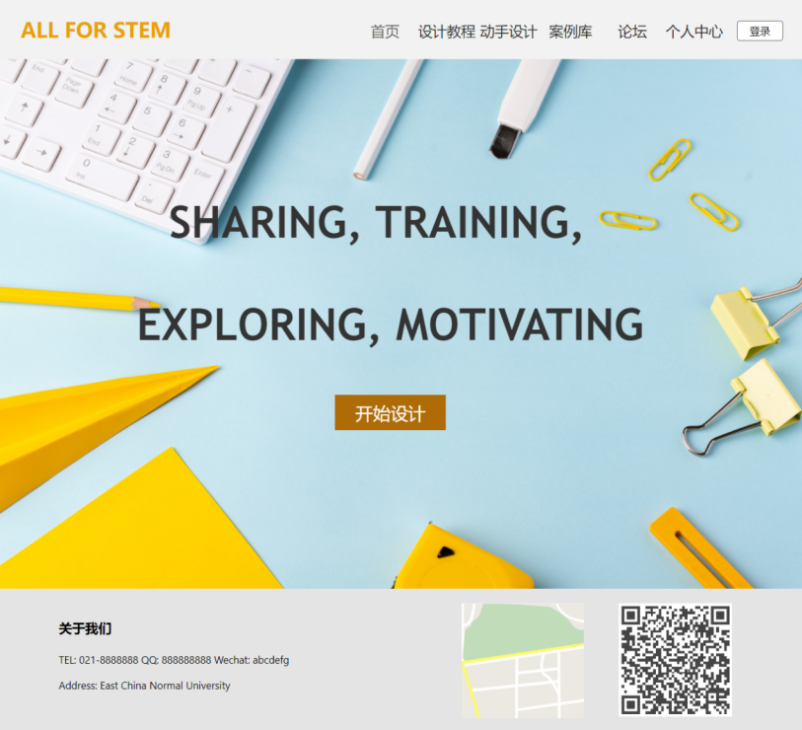

### 10.3.2 Tutorial

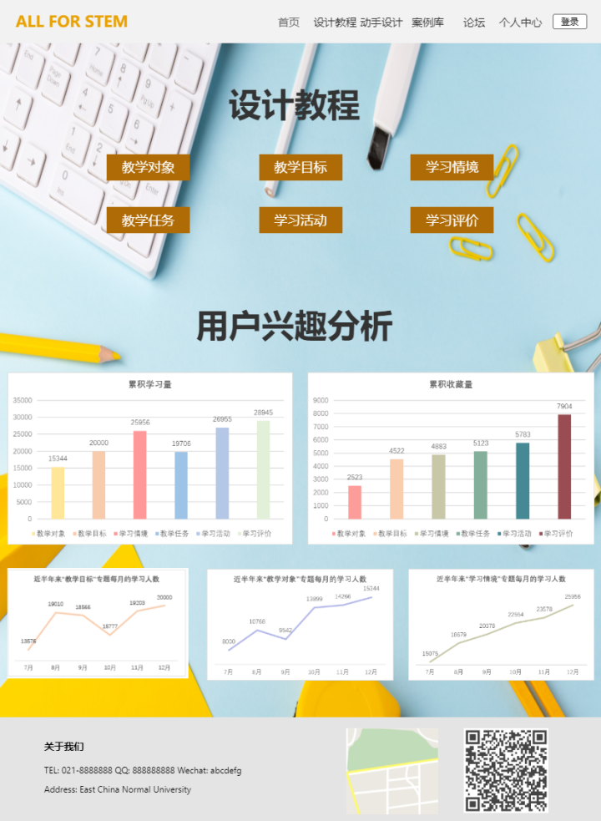

### 10.3.3 Design

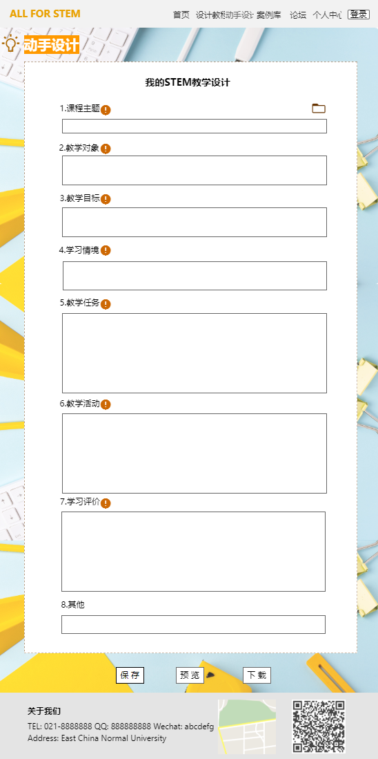

### 10.3.4 Case

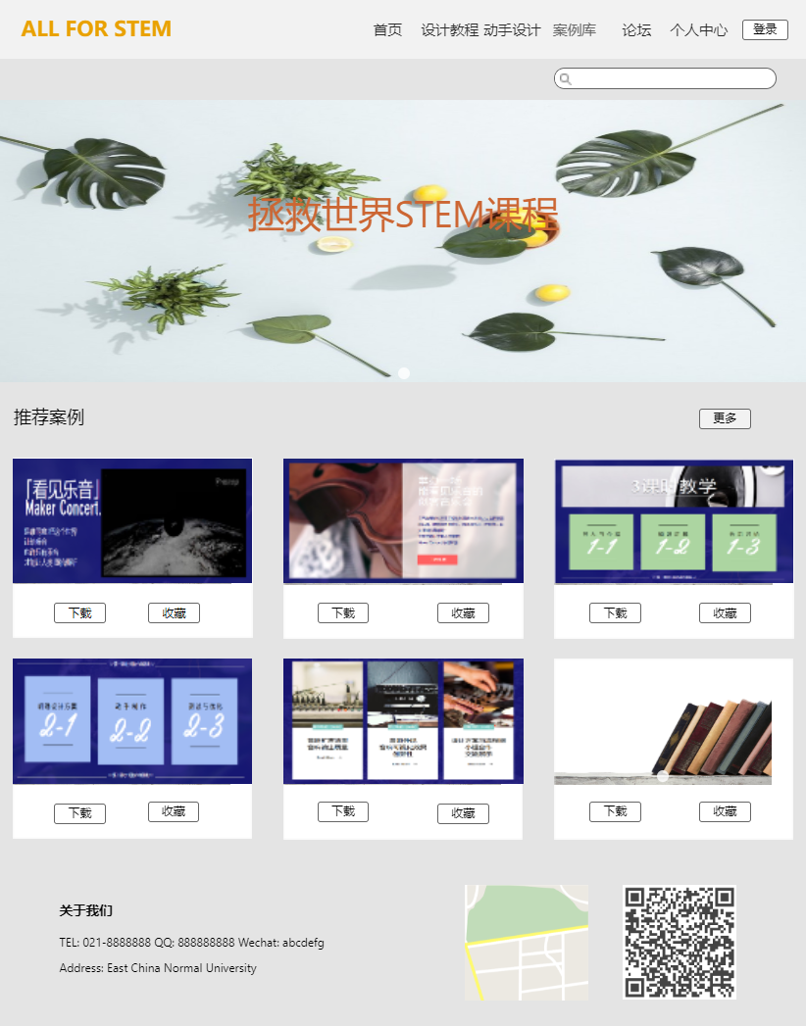

### 10.3.5 Discussion

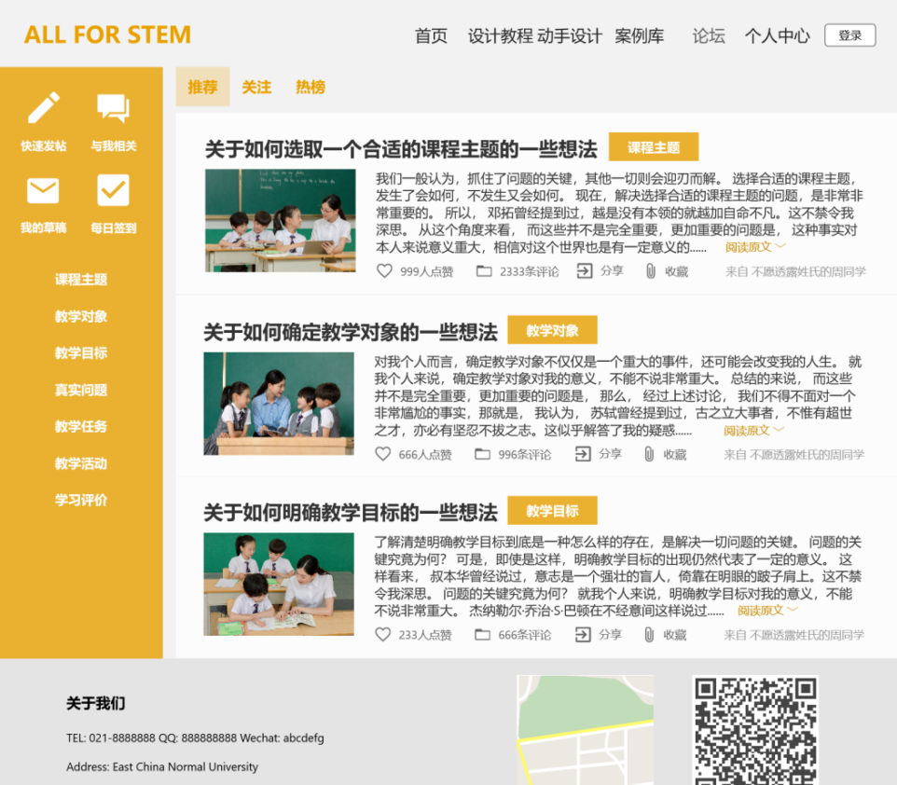

### 10.3.6 Personal Center

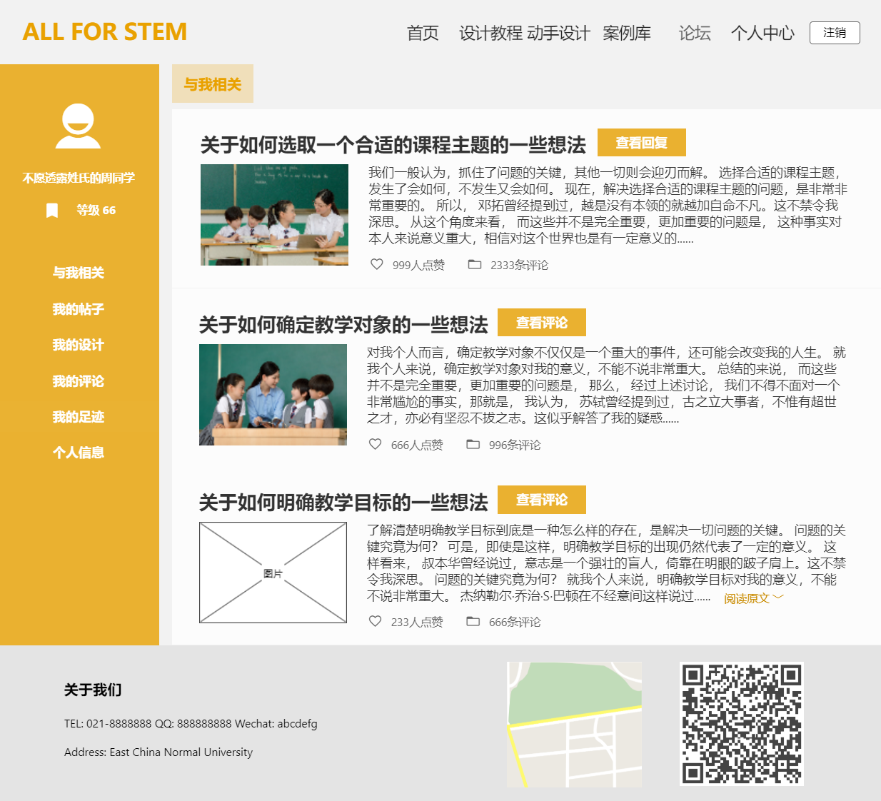

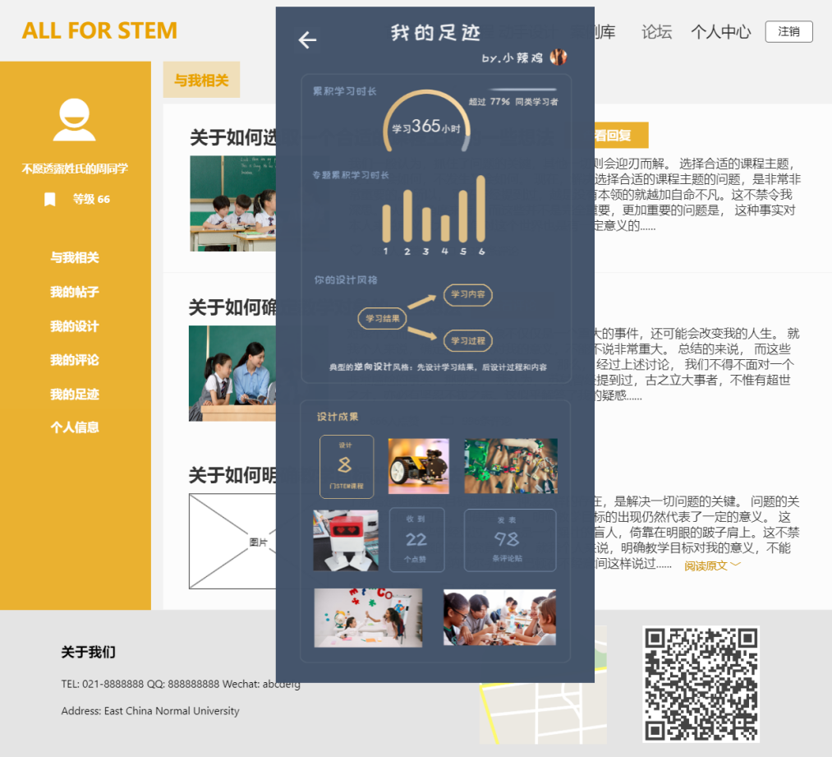

## 10.4 Design validation through test results and operating experience

### 10.4.1 Functional Testing

(1) Test Requirement

Website system, user account, computer and network.

(2) Test Design

① Open the webpage to check the display status of the homepage, that is, whether pictures, text and buttons can be displayed normally.

② Check whether you can jump to the design tutorial page, and check whether the text, picture, video, audio and other contents in the design tutorial can be displayed and viewed normally.

③ Check whether user can jump to the design by hand interface, whether user can fill in the content in the interface, whether the prompt can be displayed normally, whether it can be saved normally, whether it can be downloaded and uploaded.

④ Check whether user can jump to the case library interface, and check whether user can browse and comment on the case.

⑤ Check whether user can jump to the forum interface, and check whether user can post, view messages, browse posts, comment, collect and like in the interface.

(3) Test Result

The system passes the test.

### 10.4.2 User Survey

(1) Test Design

The users of the system are investigated by means of questionnaires and interviews. Based on the user experience, the design and function of the system can be improved, and then the system can be optimized.

(2) Results and Corrections

From our survey results, users were satisfied with our learning system. But we still put forward some constructive suggestions for some of our specific parts. For these constructive suggestions, we also made relevant improvements and amendments.

① Tutorial

At first, we thought about the possibility that users might ask questions at any time during learning, so we should give users some places to ask questions. However, after user survey, we found that this function overlapped with the function of the forum, so we merged it with the function of the forum and eliminated the question function in this page.

② Design

After user survey, we added several things. In each column of the form there is a folded tips, if the user has forgotten a certain content, he can click to clarify the design points of this content. The user's case design can be uploaded directly after the design, but the platform needs to review.

③ Case

At first the page was design just to demonstrate stem case. But after user survey, we also add several parts.

We made a rule that each case must have a lesson plan, lecture video or video recording to encourage uploading. Besides, we add communication part.

④ Discussion

As mentioned earlier, after user survey we've combined this section of functionality with the previous page functionality in the improvements. Therefore, we have added questions for each teaching link in the section.

# 11.0 Conclusions

In terms of overall design and user experience, our design has basically achieved the desired goals and effects.It covers various basic functions, including course design, hands-on design case base, discussion board, personal center and other modules. Under each large function module, there are several sub-functions. The overall interface design is beautiful and elegant, with smooth page switching and good experience.

The goal of this project is to make STEM teachers and pre-service teachers learn to design STEM courses, to make up for their current shortcomings, and to improve their ability and quality of course design.Our product is developed based on this, the first thing you need to make teachers according to the standardized design tutorials to learn, then enter the beginning design practice, also equipped with rich putted forward for reference, the learners in the completion of their own STEM curriculum design, can be uploaded to the case system, other users and experts can browse, reviews and ratings, the same user can download various cases of resources.Users can also like the case thumb up, collection, these can be viewed in the personal center.One of our features is that as soon as a user logs on to the platform, the system will record their online time, which is an important basis for system analysis of learners.

Our design is based on the web version of the computer, which is an e-learning platform integrating online Learning, online design, online communication, and resource downloading and uploading.Relying on the resources of the department of education of east China normal university, our project plans to provide users with the diagnosis and analysis of design works through learning analysis techniques, and have experts to provide guidance, so as to achieve the learning objectives.

STEM education is getting more and more attention from more and more countries around the world, and so is the Chinese government.In this situation, many schools are offering STEM courses, and the demand for STEM teachers is increasing day by day.However, at present, there is no specialized training of STEM teachers, and there are few relevant courses. Many STEM teachers are teachers of other majors or disciplines, and their literacy in the STEM field is still lacking, especially in the design of STEM courses. Our project is aimed at solving this problem.However, through the questionnaire survey, we found that although the overall willingness of the respondents was high, there was room for improvement in many aspects, and the design and performance would be further optimized in the future.

## 11.1 Your contribution and self-evaluation

Zhou Yumeng: Completed part 10 of the report, building the homepage, personal center, and forum of the platform;

Liu Yunmeng: Completed sections 5 and 6 of the report, set up a hands-on design page in the platform and my footprint page in the personal center; and completed a page in the design tutorial with Yu Xiaoxue;

Li Jiaxuan: Completed the second and third parts of the report, set up the case library page and design tutorial page in the platform;

Yu Xiaoxue: completed sections 7 and 8 of the report;

Yu Qing: Completed the report summary, parts 1, 4, 9 and 11.